Official Plan Amendment OPA-2026-05
To amend the Rural Municipality of North Shore 2021 Official Plan

Effective Date
The effective date of the Official Plan Amendment OPA-2026-05 amending the 2021 Official Plan is the date as signed below by the minister responsible for the Planning Act.

Authority
This Official Plan Amendment is made under the authority of the Planning Act R.S.P.E.I. 1988, Cap. P-8 and the Municipal Government Act R.S.P.E.I. 1988, Cap. M-12.1.
BE IT ENACTED by the Council of the Rural Municipality of North Shore that the 2021 Official Plan is amended as follows:
- Section 3.7 of the Official Plan is amended by striking out text and adding text as shown below in bold and strikeout:
3.7 Transportation Network
The Municipality does not own or have direct responsibility for any of the public or private roads; however, through the provision of land use planning the Municipality does have an important role in transportation planning. Council currently works with the provincial department responsible for transportation and infrastructure to ensure the existing public transportation network is safe and well maintained. However, most residential subdivisions within the Municipality are currently serviced by private roads, over which the Province and the Municipality have no authority that are not owned or maintained by the Province or the Municipality. Provincial services such as snow clearing, garbage collection and school buses are not offered to properties serviced by private roads. As such, the development of new private roads is no longer generally not permitted within the Municipality, except where expressly permitted by this Plan and the Land Use Bylaw, such as within lands designated Resort and zoned Resort (RES), where long-term ownership, maintenance, emergency access, and municipal non-assumption responsibilities are clearly established.
- Subsection 6.2, clause iii of the Official Plan is amended by striking out text and adding text as shown below in bold and strikeout:
iii. Support new resource-related commercial and industrial development, as well as services related to the tourism sector, and resort-oriented mixed-use development in appropriate areas, where potential land use conflicts can be mitigated and adequate servicing, access, environmental protection, and infrastructure maintenance can be demonstrated.
- Clause 7.2.5(b) of the Official Plan is amended by striking out text and adding text as shown below in bold and strikeout:
b. All land currently in a non-resource commercial or industrial use will be zoned as General Commercial (C) or Light Industrial (M1) Commercial (C) or Industrial (I) respectively on the Zoning Map.
- Section 7.2 of the Official Plan is amended by adding a new Section 7.2.7 after Section 7.2.6 as shown below in bold:
7.2.7 Resort Designation Policy
Resort-oriented mixed-use development may be supported where it contributes to the Municipality’s tourism economy, provides recreational or visitor-serving amenities, and is designed to be compatible with the Municipality’s rural, coastal, agricultural, and environmental context.
The Resort designation is intended to accommodate land uses that may include tourism establishments, resort residential uses, restaurants, retail stores, health and wellness services, event venues, active and commercial recreation uses, parks, trails, marine access where appropriate, and other complementary uses that support a resort-oriented mixed-use area.
The Resort designation is not intended to enable conventional residential subdivisions or primarily residential development on private roads. Private residential uses within the Resort designation shall be integrated with and complementary to a resort-oriented mixed-use development, and shall not be the primary purpose of a Resort designation or Resort (RES) Zone amendment.
Lands shall only be designated Resort where Council is satisfied that the lands are suitable for the intended scale and form of development, and that the development can be supported without undue negative impact on neighbouring properties, agricultural lands, environmentally sensitive areas, public safety, municipal finances, or the broader rural character of the Municipality.
Plan Actions:
a. | The Land Use Bylaw will establish a Resort (RES) Zone to support resort-oriented mixed-use development within the Resort designation.
b. | The Resort (RES) Zone may permit a range of resort-oriented tourism, residential, commercial, recreational, marine access, open space, and supporting infrastructure uses.
c. | The Land Use Bylaw will establish development standards for lands in the Resort (RES) Zone, including lot size, frontage, lot coverage, setbacks, building height, parking, servicing, access, and other matters necessary to ensure compatibility with adjacent land uses.
d. | Resort development shall be subject to all applicable provincial and federal approvals, including requirements related to subdivision, roads, water supply, wastewater treatment, wetlands, watercourses, coastal areas, dunes, environmental buffers, public safety, building standards, and tourism licensing, as applicable.

- Section 7.2 of the Official Plan is amended by adding a new Section 7.2.8 after Section 7.2.7 as shown below in bold:
7.2.8 Resort Redesignation and Rezoning Policy
Applications to amend the Future Land Use Map to designate lands as Resort, and to rezone lands to the Resort (RES) Zone, shall be reviewed in accordance with the policies of this Plan and the amendment review process established in the Land Use Bylaw.
When reviewing future applications to designate lands as Resort and/or rezone lands to the Resort (RES) Zone, Council may consider whether the proposed designation and rezoning are appropriate having regard to the scale, nature, location, servicing, access, environmental conditions, compatibility, and long-term management of the proposed resort-oriented mixed-use development.
Plan Actions:
a. | In reviewing an application to designate lands as Resort and/or rezone lands to the Resort (RES) Zone, Council may consider the following, as applicable:  i. a written description of the proposed resort development, including the intended tourism, residential, commercial, recreational, open space, marine access, and supporting infrastructure uses;  ii. a concept plan showing the general location of proposed land uses, development areas, lots or development blocks, roads, private roads or rights-of-way, trails, parking areas, open space, environmental features, buffers, and servicing infrastructure;  iii. the proposed number and general type of lots, dwelling units, accommodation units, commercial buildings, recreational facilities, and other major development components;  iv. the proposed phasing of subdivision and development;  v. the proposed means of water supply, wastewater treatment, stormwater management, and utility servicing;  vi. the proposed road, private road, access, emergency access, parking, pedestrian circulation, and active transportation network;  vii. the proposed ownership, maintenance, and management structure for private roads, private services, open space, trails, recreational amenities, and other common infrastructure;  viii. whether the proposed development includes a meaningful tourism, recreation, accommodation, visitor-serving, commercial, open space, or resort amenity component sufficient to establish the development as a resort-oriented mixed-use development rather than a conventional residential subdivision;  ix. identification of wetlands, watercourses, dunes, coastal areas, environmental buffers, flood-risk areas, erosion-risk areas, and any other environmentally sensitive features;  x. a description of measures proposed to avoid or mitigate impacts on adjacent land uses, agricultural lands, natural areas, public access, traffic safety, municipal services, and municipal finances;  xi. any proposed covenants, easements, subdivision agreements, development agreements, utility agreements, or other instruments intended to implement or maintain the resort development; and  xii. any additional information required by Council or the Development Officer to determine whether the proposed Resort designation and/or Resort (RES) rezoning is consistent with the objectives and policies of this Plan.
b. | Council may refuse an application to designate lands as Resort and/or rezone lands to the Resort (RES) Zone where Council is not satisfied that the proposed development can be adequately serviced, accessed, phased, maintained, and developed in a manner that is compatible with adjacent lands, environmental constraints, municipal finances, public safety, and the policies of this Plan.
c. | Where lands are designated Resort and/or rezoned to the Resort (RES) Zone, subdivision and development shall proceed in accordance with the Land Use Bylaw and any applicable subdivision approval, development approval, subdivision agreement, development agreement, restrictive covenant, easement, servicing agreement, utility agreement, road maintenance agreement, or other implementing instrument.
d. | Council may require agreements or other instruments as a condition of redesignation, rezoning, subdivision approval, or development approval, where such agreements or instruments are authorized by law and are necessary to address matters including private infrastructure, common areas, roads, services, environmental protection measures, phasing, long-term maintenance, and municipal non-assumption.
e. | Council may refuse an application to designate lands as Resort and/or rezone lands to the Resort (RES) Zone where Council determines that the proposed development is primarily a conventional residential subdivision, that private residential uses are not sufficiently integrated with or functionally related to a resort development, or that the proposed resort, tourism, recreation, accommodation, visitor-serving, commercial, open space, or resort amenity components are speculative, incidental, or insufficient to support the Resort designation.
f. | Where application to designate lands as Resort and/or rezone lands to the Resort (RES) Zone on lands that are adjacent and under shared ownership with existing Resort designated property(RES) Zone Council will consider existing Resort plans and allow for amendments to plans as necessary.
g. | During the next comprehensive review of this Plan and the Land Use Bylaw, Council shall consider whether to establish a more formal planning and implementation framework for comprehensively planned resort development, which may include the use of development agreements, subdivision agreements, special zoning tools, or other mechanisms authorized by the Planning Act or other applicable legislation.

- Subsection 8.2.3 of the Official Plan is amended by striking out the existing policy statement and replacing it with the text shown below in bold and strikeout:
All new roads constructed shall meet minimum development standards as established by the Province, at the developer’s expense, and shall be deeded to the Province.
Public roads constructed in the Municipality shall meet minimum development standards established by the Province and shall be deeded to the Province where required by legislation, regulation, or bylaw. Private roads may be considered only where expressly permitted by this Plan and the Land Use Bylaw, and where long-term ownership, maintenance, emergency access, engineering certification, and municipal non-assumption responsibilities are clearly established.
- Clause 8.2.3(a) of the Official Plan is amended by striking out the existing wording and replacing it with the text shown below in bold and strikeout:
a. All new roads constructed shall meet minimum development standards as established by the Province, and the road will be deeded to the Province as a public right-of-way prior to the approval of any development applications for properties with access to the new road. No new private or seasonal roads will be permitted.
a. Except as otherwise provided in this Plan, all new roads constructed as part of a subdivision shall meet minimum development standards established by the Province and shall be deeded to the Province as a public right-of-way prior to the approval of development applications for properties with access to the new road.
- Subsection 8.2.3 of the Official Plan is amended by adding new clauses after clause 8.2.3(b) as shown below in bold:
c. Private roads may be permitted within lands designated Resort and zoned Resort (RES), where the private road is part of a resort development, provides safe and convenient access to a public road, is designed by, constructed under the supervision of, and certified by a professional engineer to the satisfaction of the Municipality, and is subject to legal agreements or other instruments addressing ownership, maintenance, repair, snow clearing, drainage, emergency access, civic addressing, solid waste collection, and municipal non-assumption.
d. Where a property is served by a private road, the Municipality shall not be deemed responsible for the construction, maintenance, repair, grading, ditching, snow clearing, replacement, or upgrading of the private road unless such road has been formally accepted as a public road suitable for year-round use.
e. The Land Use Bylaw may establish standards and application requirements for private roads in the Resort (RES) Zone, including requirements for rights-of-way, road width, emergency access, legal access, engineering design, construction supervision, engineer certification, as-built drawings, registration of agreements, notice to purchasers, and independent engineering review where required by the Municipality.
- Subsection 8.2.6 of the Official Plan is amended by striking out the existing policy statement and replacing it with the text shown below in bold and strikeout:
Properties will operate on privately owned on-site sewage disposal systems.
Properties will generally operate on privately owned on-site sewage disposal systems. Privately owned communal or central sewage disposal systems may be considered where such systems are permitted by provincial legislation and are designed, approved, constructed, operated, maintained, and monitored in accordance with all applicable provincial requirements.
- Subsection 8.2.7 of the Official Plan is amended by striking out the existing policy statement and replacing it with the text shown below in bold and strikeout:
Properties will operate on privately owned water supply systems.
Properties will generally operate on privately owned water supply systems. Privately owned communal or central water supply systems may be considered where such systems are permitted by provincial legislation and are designed, approved, constructed, operated, maintained, and monitored in accordance with all applicable provincial requirements.
- Clause 10.2.5(e) of the Official Plan is amended by adding marine access structures as shown below in bold:
e. Fishing sheds, aquaculture facilities, boat launching facilities and wharves, and other Marine Access Structures will be permitted, according to municipal, provincial, and federal regulations.

- Appendix A: Future Land Use Map of the Official Plan is amended by replacing the Future Land Use Map with the revised Future Land Use Map shown below:
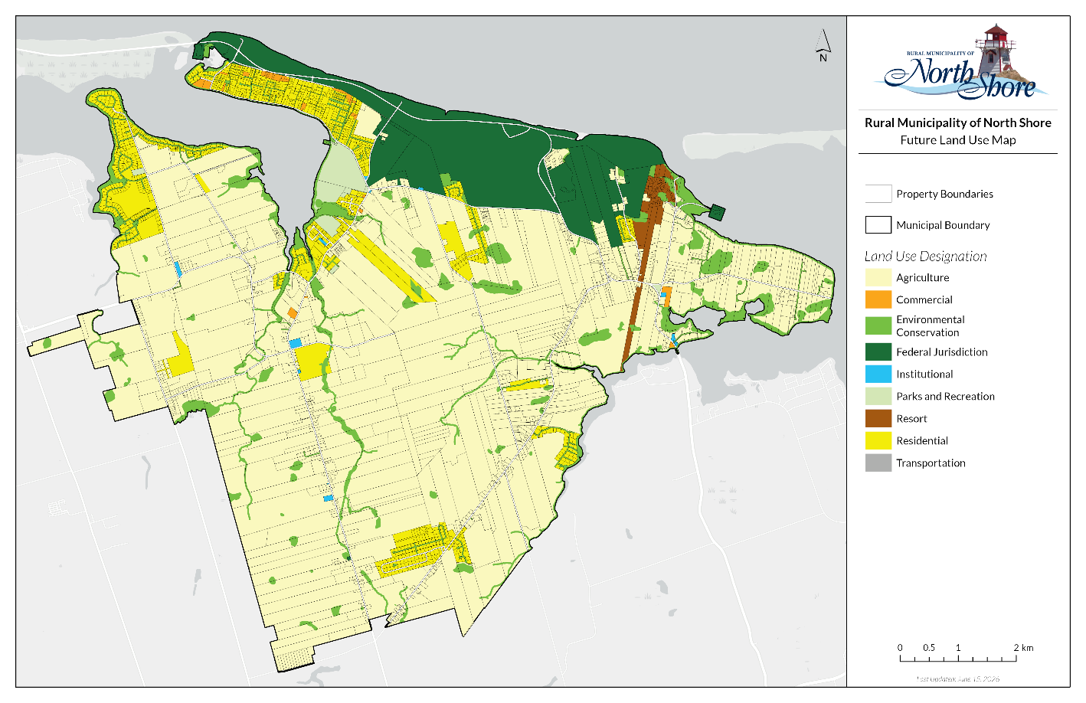
Figure 1 - Revised Future Land Use Map

Adoption and Approval by Council
The Rural Municipality of North Shore Official Plan Amendment OPA-2026-05 was approved and adopted by a majority of council members present at the Council meeting held on DATE.
The Rural Municipality of North Shore Official Plan Amendment OPA-2026-05 was declared to be passed on DATE.

Mayor |  | Chief Administrative Officer
(signature sealed) |  | (signature sealed)

Ministerial Approval
The Rural Municipality of North Shore Official Plan Amendment OPA-2026-05 is hereby approved.
Hon. Darlene Compton  Minister of Land and Environment |  | Date

