Public Meeting

Amendment to Official Plan and Land Use Bylaw

June 22, 2026 – 6:00 p.m.

A meeting will be held at the North Shore Community Centre, 2120 West Covehead, to receive comments from the public on the following proposed amendments to the Official Plan and Land Use Bylaw:
- Official Plan Text Amendments – updates to policies establishing a new Resort designation and required information, updating the future land use map direction, permitting private roads in resort developments, updating language regarding water and wastewater servicing and housekeeping amendments updating language around marine access and marine access structures and coordinating designation and zone titles.
- Land Use Bylaw Textual Amendments – to create a Resort (RES) Zone for resort-oriented mixed-use developments, including tourism accommodations, limited residential uses, recreation, commercial services, marine access, and related infrastructure. The amendments would also add supporting rules for private roads in Resort zones and related subdivision requirements, and to clarify changes for marine access and coastal provisions to recognize limited exceptions for approved fisheries, aquaculture, marine access structures, and non-habitable structures required for permitted water-dependent uses.
- Land Use Bylaw Housekeeping Amendments – to clarify parking requirements on properties with more than one use, the application of secondary suite provisions, and new or revised definitions for resort development, marina, marine access structure, commercial recreation use, event venue, craft brewery or distillery, art gallery, and related tourism establishment terminology.
- Map Amendments: Official Plan Future Land Use Map and Land Use Bylaw Zoning Map – amendments to PIDs s 141853, 141937, 142133, 421834, 430421, 534891,696740, 723932, 730986, 781377, 793786, 793802, 863902, 900043, 1004795, 1148246, 1148253, 1179019, 1179027, and 1179035 to apply the Resort designation and zoning for the Blackbush Resort while updating the Environmental Conservation designation and zoning based on more recent environmental mapping on the subject properties, as shown in map below.
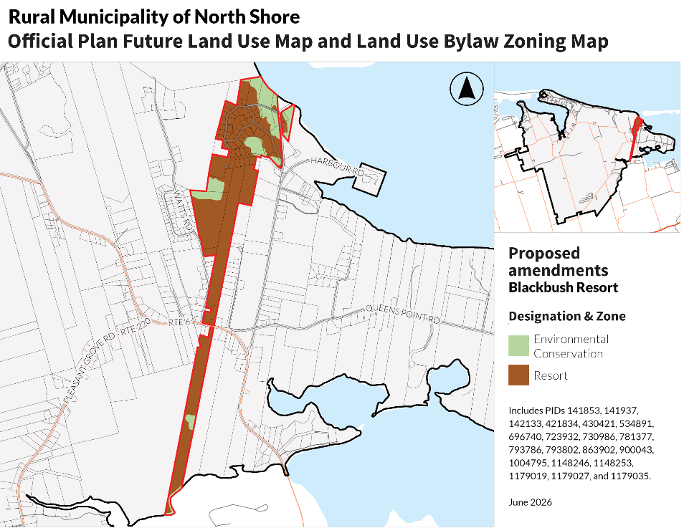
The meeting is open to the public and all interested parties are encouraged to attend. Public comments and feedback about the proposal will be accepted until June 23, 2026, at 4:00pm.
Details on the application may be viewed at the municipal office or online at https://www.northshorepei.ca/ prior to the meeting. For more information on this proposal or to provide comments, please contact the municipal office by email to administrator@northshorepei.ca or mail/delivery to 2120 Rte. 25, West Covehead, PE C0A 1P0 or call 902-672-2600.

