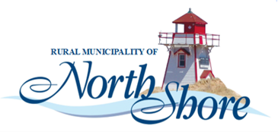
UNAPPROVED AGENDA
Regular Council – Rural Municipality of North Shore
Wednesday September 16th, 2026 @ 6:30 pm
North Shore Community Centre

CALL TO ORDER

APPROVAL OF THE AGENDA

Disclosure of Pecuniary (Financial) or other Conﬂicts of Interest

APPROVAL OF THE MINUTES

Regular Council – July 15th, 2026

Business arising from the minutes

REPORTS

CAO Report

Finance Report

EMO Report

Wellness and Recreation

Development & Planning Report

NEW BUSINESS

RFD- 2026-018 -RZ-PID# 138263

Resolution to hire a second Development Officer for evaluation and permit approval when the main development officer is in conflict or on leave.

IN CAMERA SESSION: MGA - 119. Closed meetings

NEXT MEETING September 16th at 6:30 pm, North Shore Community Centre

ADJOURNMENT

