Rural Municipality of North Shore – Public Meeting

October 15, 2026 – 6:00 p.m.
September 28, 2026
Subject: Zoning amendments to Official Plan and Land Use Bylaw – PID 138263 on the West Covehead Rd.
Dear Landowner,
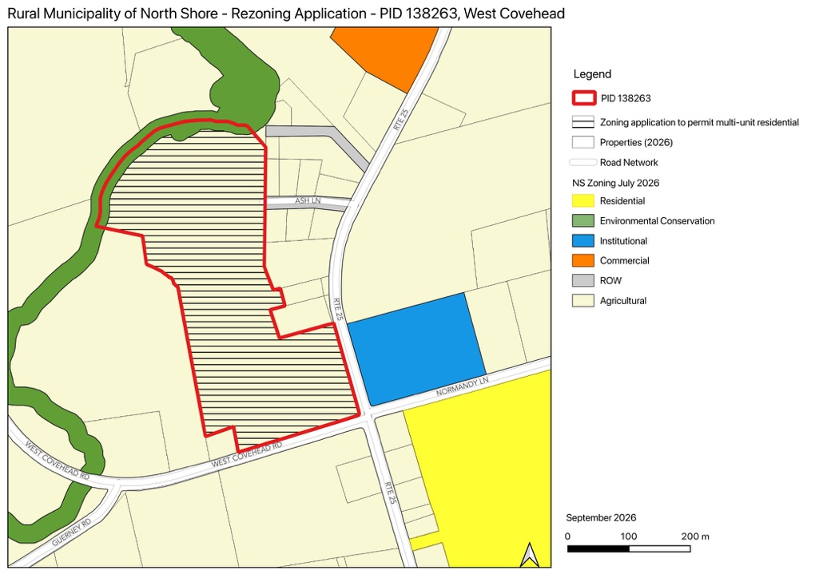
A meeting will be held at the North Shore community Centre, 2120 West Covehead, to receive comments from the public on the following proposed amendments to the Official Plan and Land Use Bylaw:
- Official Plan Map Amendment – to apply the Residential designation to a portion of PID 138263 on the Future Land Use Map
- Land Use Map Amendments– to apply the Multi-Unit Residential (R3) zone to a portion of PID 138263 on the Zoning Map
This is a request for a change in zoning to permit multi-unit residential uses on PID 138263 on the West Covehead Rd. The meeting is open to the public and all interested parties are encouraged to attend. Public comments and feedback about the proposal will be accepted until October 16, at 4:00pm.
Details on the application may be viewed at the municipal office or online at https://www.northshorepei.ca/ prior to the meeting. For more information on this proposal or to provide comments, please contact the municipal office by email to administrator@northshorepei.ca or mail/delivery to 2120 Rte. 25, West Covehead, PE C0A 1P0 or call 902-672-2600.

Marie McInnis
Chief Administrative Officer
Rural Municipality of North Shore

